|  |  |  |  |
| --- | --- | --- | --- |
| Question | Q1 | Q2 | Q3 |
| Marks | 6 | 6 | 8 |
| Total | 20 | | |

**Full Name (as in course registration):**

**Date:**

**Course:** **Vision Systems**

**Question 1.** For each question, select the **single** most appropriate answer, and **provide your justification** (no longer than two sentences).

a). The LBP code studied in our course is robust to

1. Image flip (e.g., flip the image horizontally or vertically)
2. Image rotation (e.g., rotate the image clockwise or counter-clockwise)
3. Global intensity change (e.g., whole image becomes brighter or darker)
4. None of above

C

b). Suppose you are applying a sliding-window-based pre-trained HoG object classifier on the test image to perform object detection, increasing the stride (the distance the sliding window moves at each step) of the sliding window will tend to

1. Increase object detection accuracy, increase computational cost (run time).
2. Increase object detection accuracy, decrease computational cost (run time).
3. Decrease object detection accuracy, increase computational cost (run time).
4. Decrease object detection accuracy, decrease computational cost (run time).

D

Q**uestion 2.** An image with a resolution of $3×3$ pixels and its intensity values are illustrated below. For the center pixel (highlighted in black color in the image), apply the local binary pattern method to calculate its local binary code. Show your calculations.

|  |  |  |
| --- | --- | --- |
| 5 | 8 | 6 |
| 11 | 7 | 9 |
| 3 | 10 | 2 |

01010101 = 85

**Question 3.** Suppose you have a large collection of photos from your holiday trips, including (1) photos of single person face (either yourself or other person), (2) photos with multiple faces, and (3) photos without people face. These photos are stored in your personal laptop, as illustrated in the right Figure. **Propose a computer vision system to find the subset of the images that contains your face alone from this large collection of photos.** In your answer, you need to describe what computer vision methods need to be applied to achieve this objective. You could draw a flow chart or a system architecture to justify your answers.

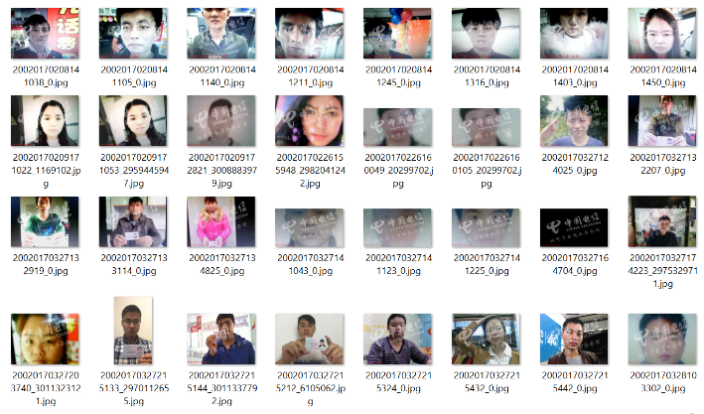Person Counting using YOLOv3/Viola Jones

Then Face Verification using HOG/Siamese network